Compiere with JasperReports 0.6.5

1 Compiere installation 1
2 Compiere preparation 1
2.1 Login 1
2.2 Create a new system element 2
2.3 Database column creation 4
2.4 Report & Process window modification 9
3 Process creation 11
3.1 Simple standalone process creation 11
3.1.1 Menu creation 13
3.1.2 Security access to new menus 16
3.2 « In window context » process creation 18
3.3 ReportType Selection 18
4 Report deployement Strategy 20
4.1 Deploy reports on the application server 21
5 Annexes 21
5.1 Standalone.jrxml 22

Compiere installation
Use my package found at http://sourceforge.net/projects/compierejaper/ (source or binaries as you want) and install Compiere normally (consult the Compiere documentation at http://www.compiere.org)

Compiere preparation
You need to add a field for storing the filename of your report.
After you can specified a different report for each process you create
Start compiere as with the Java Web Start method (http://compiere_server:port/compiere.jnlp)
Remark : You might need a JDK version not a JRE one I did not test with a JRE but I’m quite sure that the Report compilation need the JDK

Login
Log in as SuperUser with the System Administrator Role
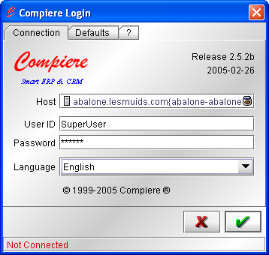
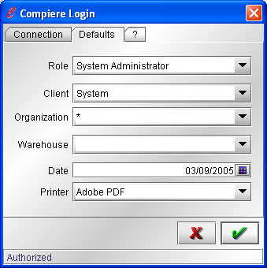

Create a new system element
Select Application Directory/Element
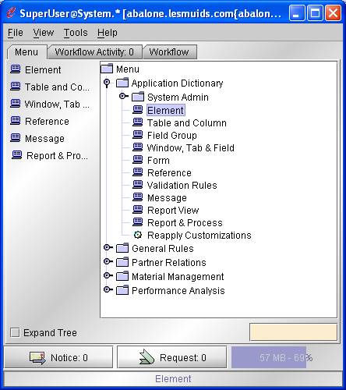
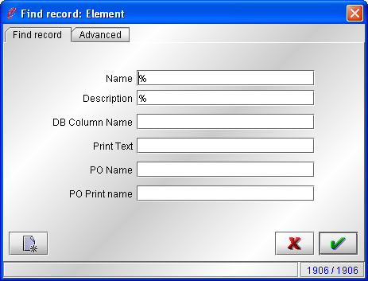
Click the « New element » icon
And fill
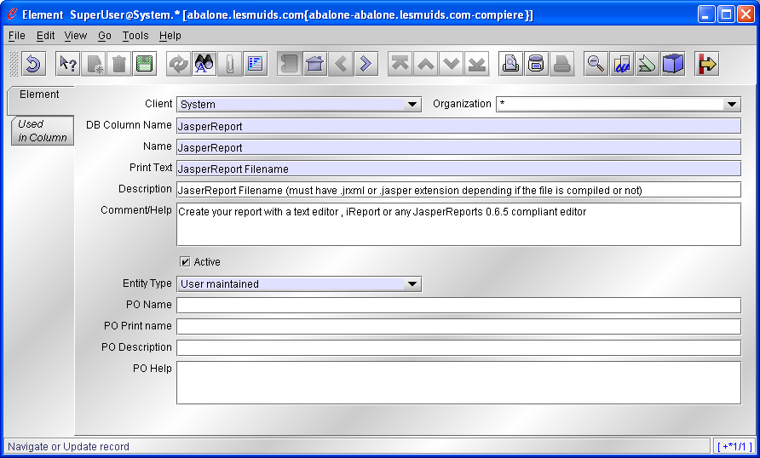
Save …

Database column creation
Now go to Application Directory/Tables and columns
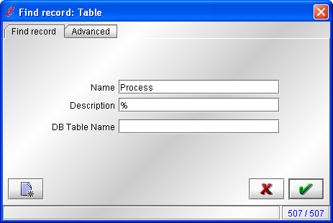
Select AD_Process
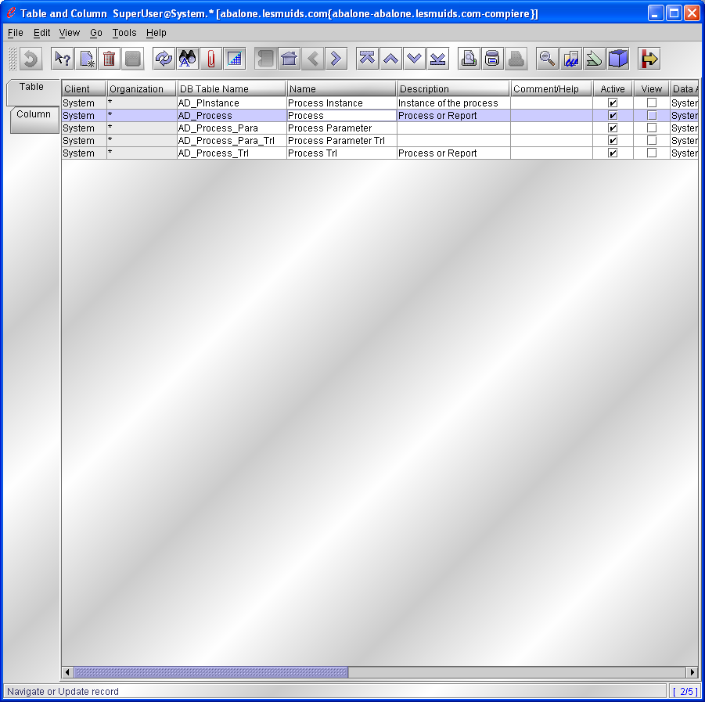
Afetr clicking select the columns tab

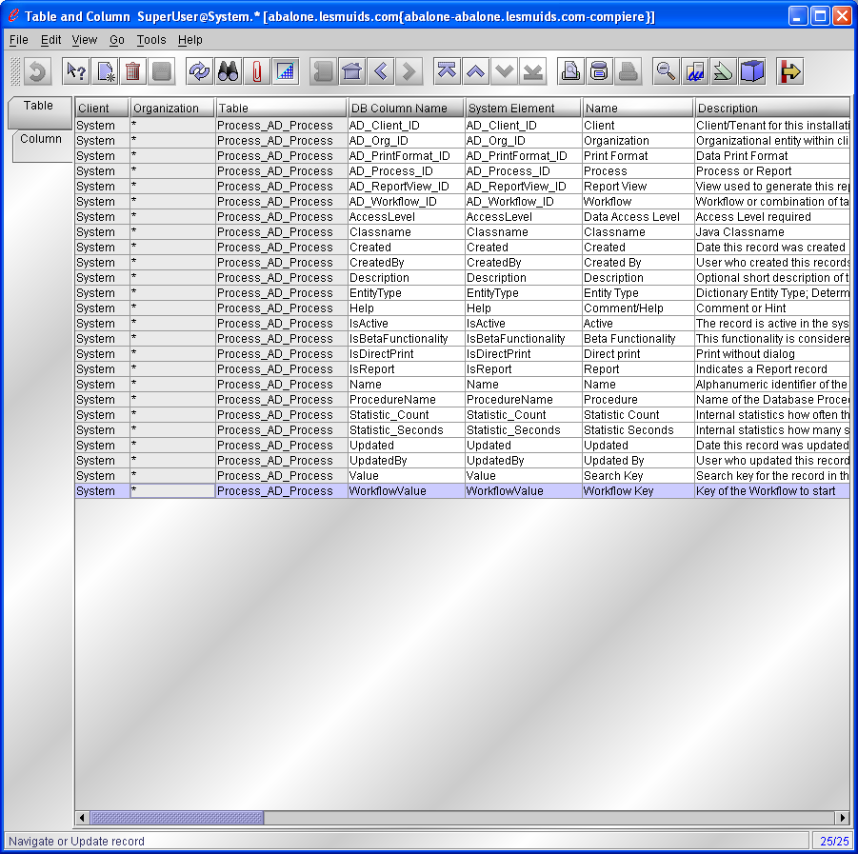
Add a new Column and change the « Data grid toggle » and fill in
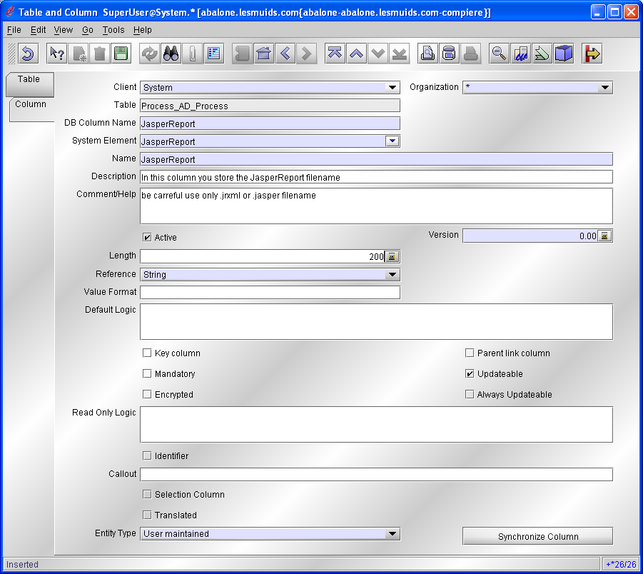
Now save and click Synchronize Column
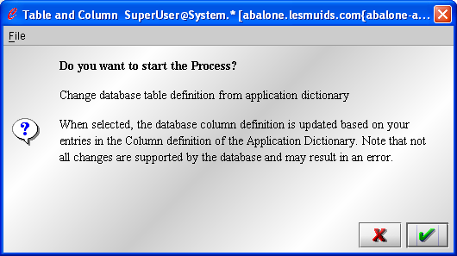
Click OK
And remark that now you have a information … ALTER TABLE…
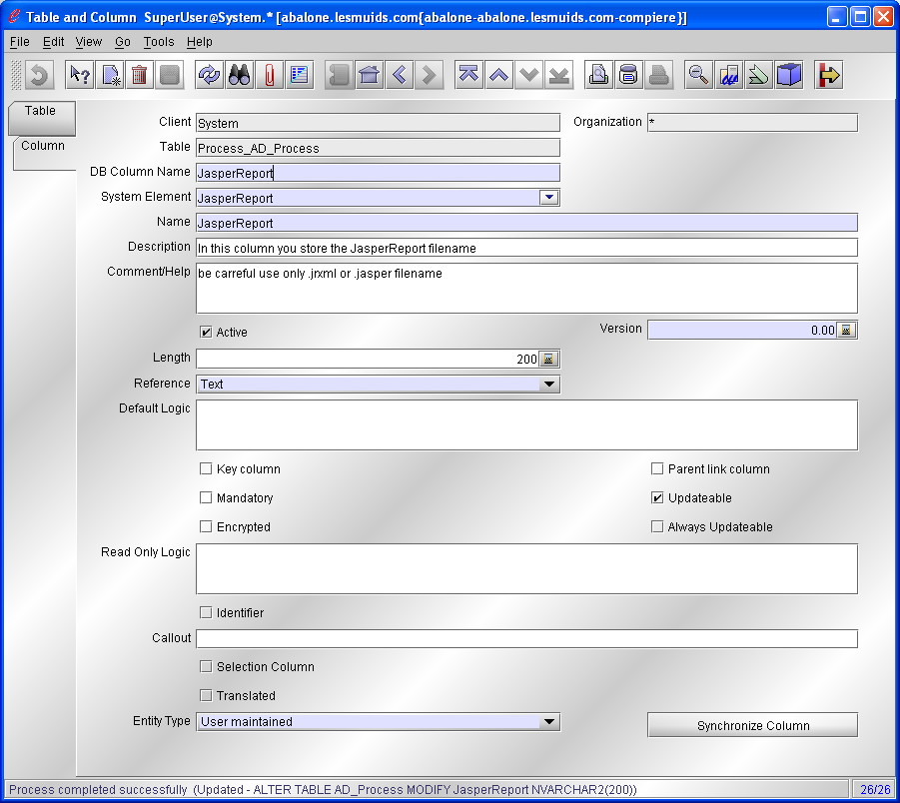
So it is OK !

Report & Process window modification
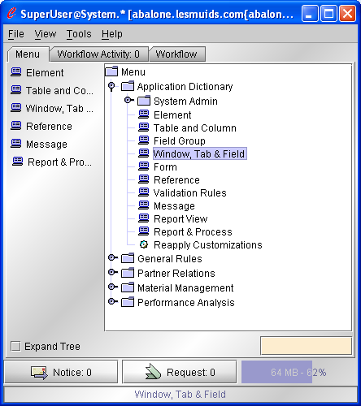
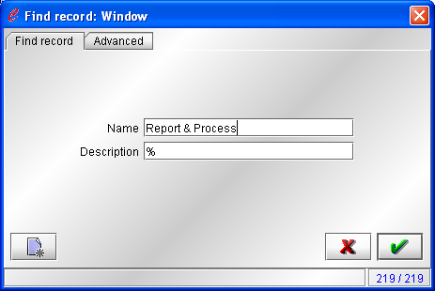
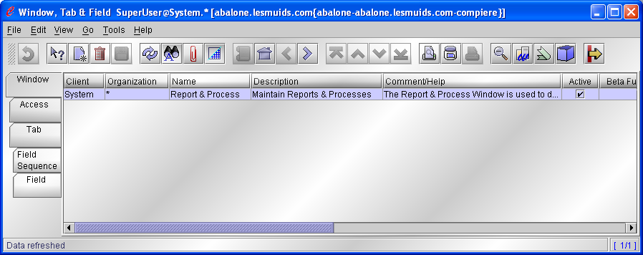
It is important to click each tab… Perhaps a bug in the current Compiere Version
now you are in the Field Tab
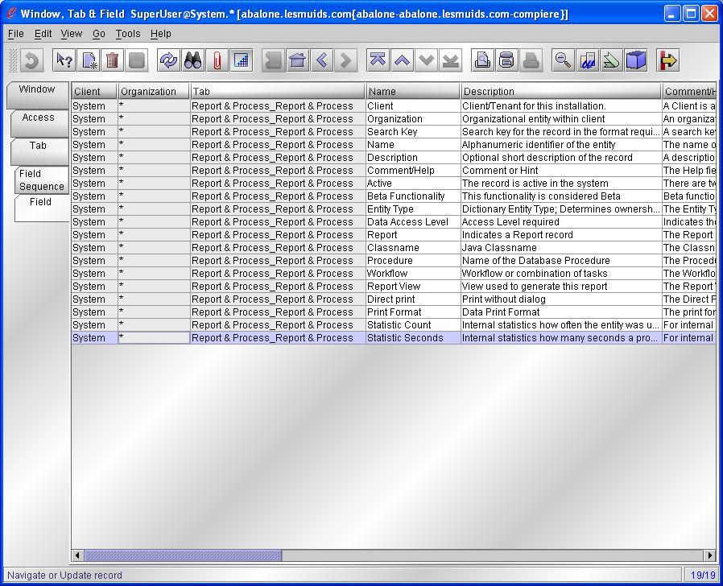
Click « New Record » and toggle the view
And fill…
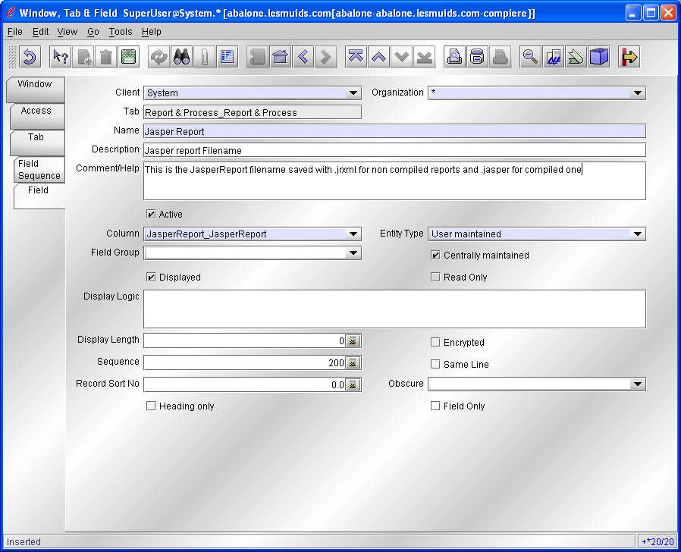

Process creation

Simple standalone process creation
In this sample we will create a process called Standalone accessible directly in the main menu
You are logged in as System Administrator role…
Go to
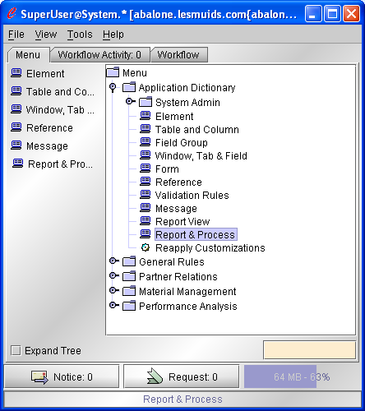
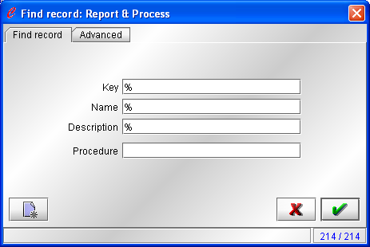
Select the « new record » icon and fill
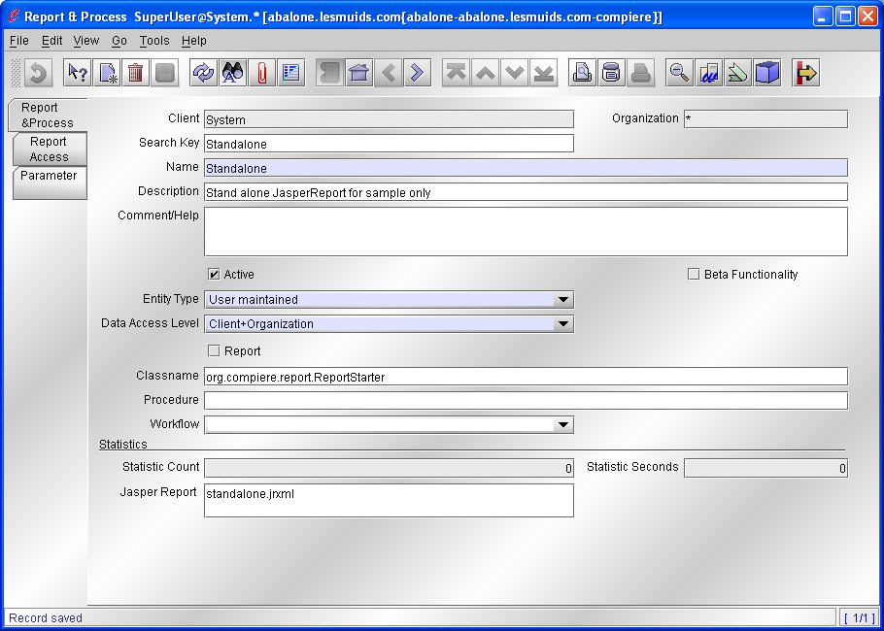

Menu creation
Go to
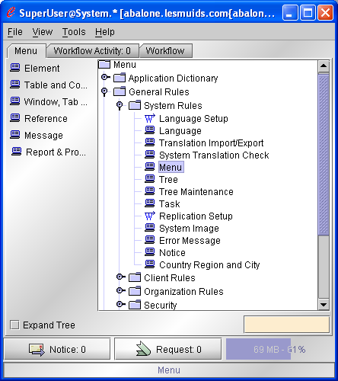
Create a new and fill
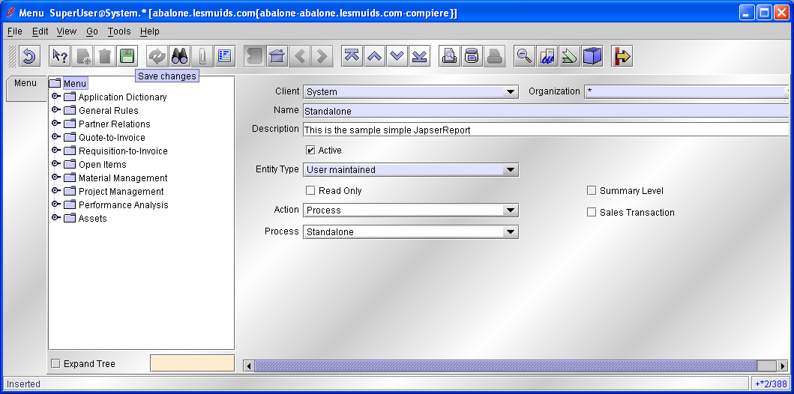
Remark : you have to logout and re log in for seing the change
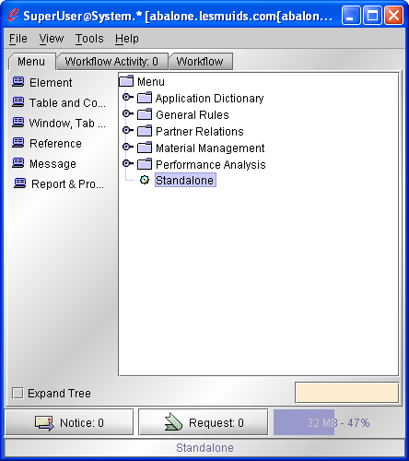
The file go in $COMPIERE_HOME/reports be carreful with some Java Web Start installations because if the COMPIERE_HOME is not set you might get something like c:\Document And Settings\user\Desktop\null as COMPIERE_HOME
It is not a problem for testing this you just have to start the process without putting the report
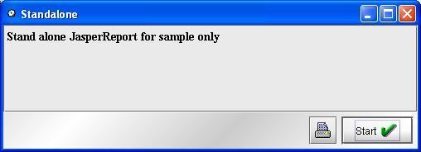
you hear a sound marking an error
Just close the window and go to the Tools/preference Menu
Select the Errors Tab and you can see exactly where Compiere is looking for your Report and this is what I get with the standalone.jrxml report deployed on the server you can find in annexe.
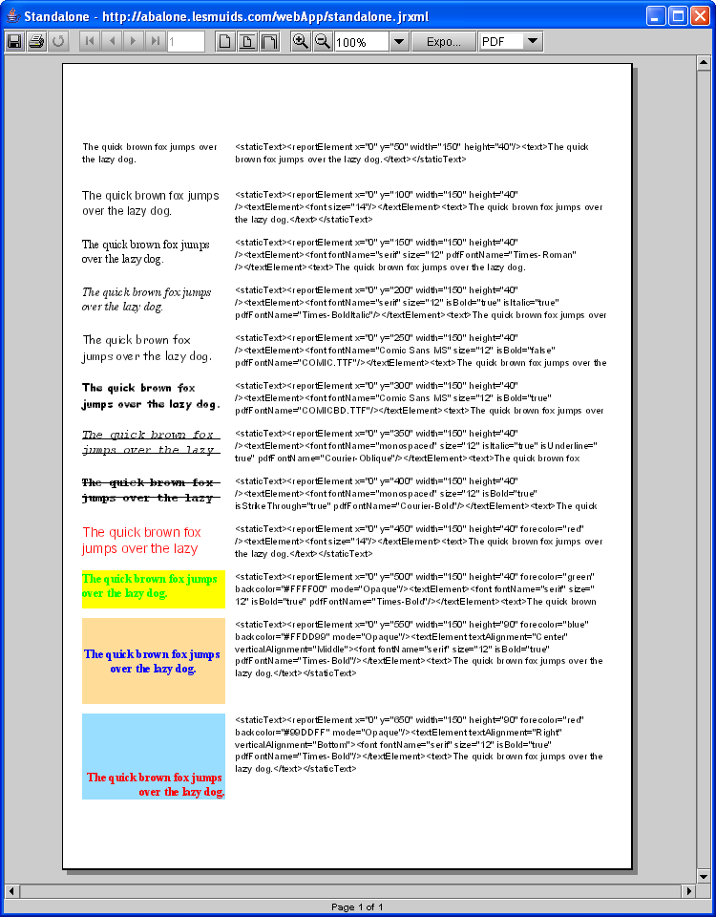
….

Security access to new menus
In order to get access to your new « Standalone » report from your your target Client Role, you need to allow access to processus
Login as your client Admin Role
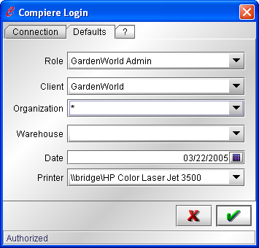
And in the main menu select the role control window
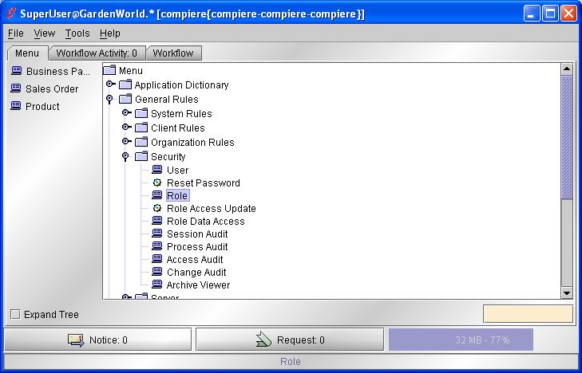
Now you can add a role accessing your process in the process Access Tab
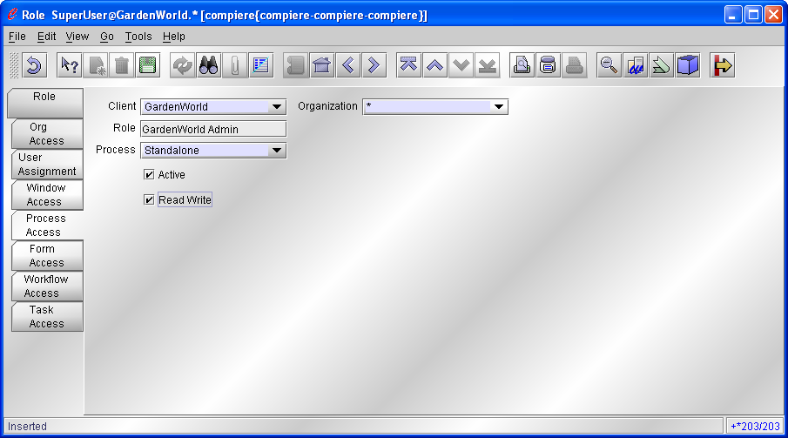
Exit and Re-log
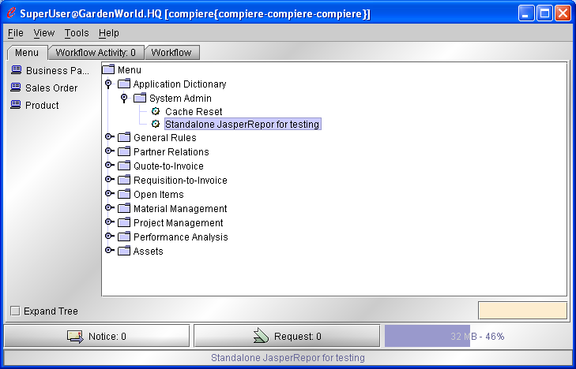
With have it now (perhaps somewhere else this print screen is buggy because my menu display name is different because I put a different name!)

« In window context » process creation

ReportType Selection
Thanks to Alin
You can now add a column type as previsiously. Add
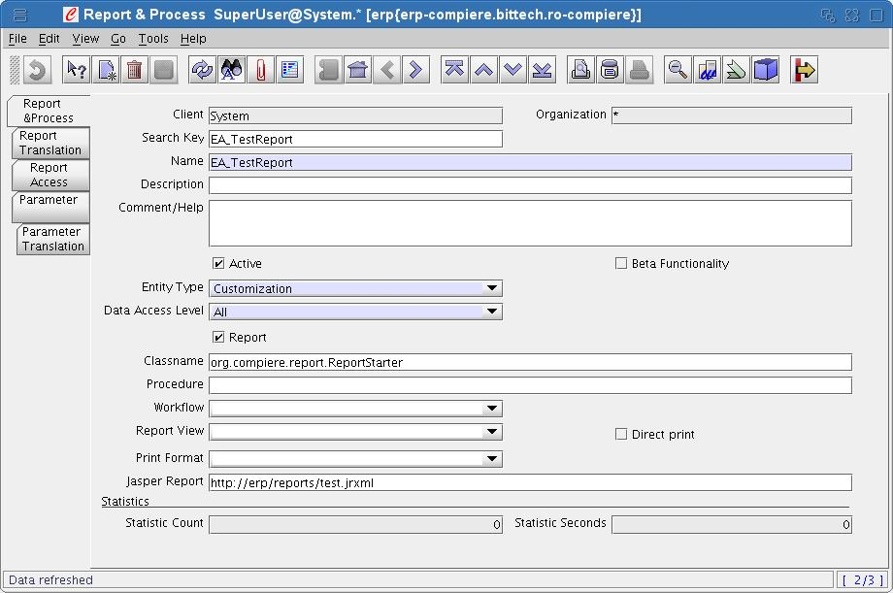
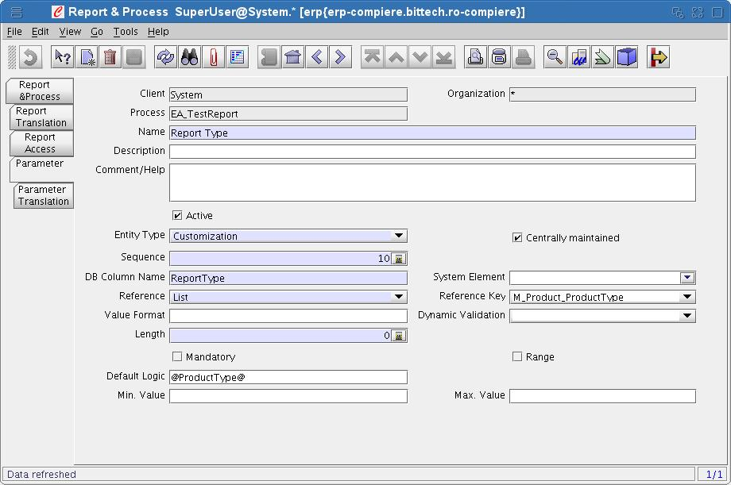

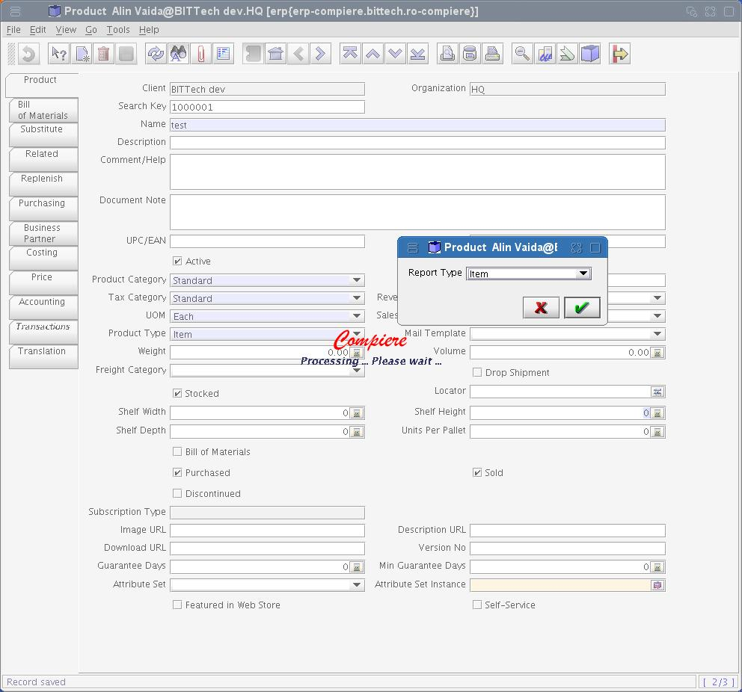
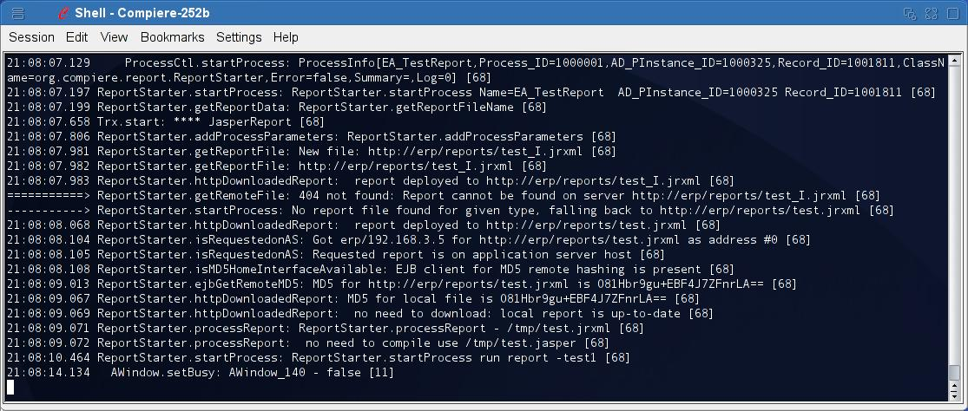

Report deployement Strategy
It is now easy to deploy reports in $COMPIERE_HOME/reports or directly on a web server
Just specify the full URL in the Report & Process/JasperReport field and the report wil be downloaded from the web server.
Note that the source jrxml is automatically stored in the local temp directory and replaced if a new version is present on the server.
Note also that the compiled version is also kept in the temp directory so the compilation is only done one time.

Deploy reports on the application server
It is probably the best method for deploying reports. You need to create a package containing your report.
The best way is to create an EAR deployement package and put it in the jboss/server/compiere/deploy directory of the application server. Jboss will detect that you add a package and deploy it automatically, if you remove it removes… it is magic.
You can find on sourceforge a webApp.ear package wich include standalone.jrxml report deployed as http://compiereservename.domain:compierewebportifnot80/webApp/standalone.jrxml

Annexes

Standalone.jrxml
<?xml version="1.0" encoding="UTF-8"?>
<!-- Created using an evaluation version of JasperAssistant (http://www.jasperassistant.com) -->
<!DOCTYPE jasperReport PUBLIC "-//JasperReports//DTD Report Design//EN" "http://jasperreports.sourceforge.net/dtds/jasperreport.dtd">

<jasperReport name="standalone" pageWidth="595" pageHeight="842" whenNoDataType="AllSectionsNoDetail" columnWidth="555" leftMargin="20" rightMargin="20" topMargin="30" bottomMargin="30">
<title>
<band height="782">
<staticText>
<reportElement x="0" y="50" width="150" height="40"/>
<textElement/>
<text><![CDATA[The quick brown fox jumps over the lazy dog.]]></text>
</staticText>
<staticText>
<reportElement x="160" y="50" width="390" height="40"/>
<textElement/>
<text><![CDATA[<staticText><reportElement x="0" y="50" width="150" height="40"/><text>The quick brown fox jumps over the lazy dog.</text></staticText>]]></text>
</staticText>
<staticText>
<reportElement x="0" y="100" width="150" height="40"/>
<textElement>
<font size="12"/>
</textElement>
<text><![CDATA[The quick brown fox jumps over the lazy dog.]]></text>
</staticText>
<staticText>
<reportElement x="160" y="100" width="390" height="40"/>
<textElement/>
<text><![CDATA[<staticText><reportElement x="0" y="100" width="150" height="40"/><textElement><font size="14"/></textElement><text>The quick brown fox jumps over the lazy dog.</text></staticText>]]></text>
</staticText>
<staticText>
<reportElement x="0" y="150" width="150" height="40"/>
<textElement>
<font fontName="serif" size="12" pdfFontName="Times-Roman"/>
</textElement>
<text><![CDATA[The quick brown fox jumps over the lazy dog.]]></text>
</staticText>
<staticText>
<reportElement x="160" y="150" width="390" height="40"/>
<textElement/>
<text><![CDATA[<staticText><reportElement x="0" y="150" width="150" height="40"/><textElement><font fontName="serif" size="12" pdfFontName="Times-Roman"/></textElement><text>The quick brown fox jumps over the lazy dog.</text></staticText>]]></text>
</staticText>
<staticText>
<reportElement x="0" y="200" width="150" height="40"/>
<textElement>
<font fontName="serif" size="12" isBold="true" isItalic="true" pdfFontName="Times-BoldItalic"/>
</textElement>
<text><![CDATA[The quick brown fox jumps over the lazy dog.]]></text>
</staticText>
<staticText>
<reportElement x="160" y="200" width="390" height="40"/>
<textElement/>
<text><![CDATA[<staticText><reportElement x="0" y="200" width="150" height="40"/><textElement><font fontName="serif" size="12" isBold="true" isItalic="true" pdfFontName="Times-BoldItalic"/></textElement><text>The quick brown fox jumps over the lazy dog.</text></staticText>]]></text>
</staticText>
<staticText>
<reportElement x="0" y="250" width="150" height="40"/>
<textElement>
<font fontName="Comic Sans MS" size="12" isBold="false" pdfFontName="COMIC.TTF"/>
</textElement>
<text><![CDATA[The quick brown fox jumps over the lazy dog.]]></text>
</staticText>
<staticText>
<reportElement x="160" y="250" width="390" height="40"/>
<textElement/>
<text><![CDATA[<staticText><reportElement x="0" y="250" width="150" height="40"/><textElement><font fontName="Comic Sans MS" size="12" isBold="false" pdfFontName="COMIC.TTF"/></textElement><text>The quick brown fox jumps over the lazy dog.</text></staticText>]]></text>
</staticText>
<staticText>
<reportElement x="0" y="300" width="150" height="40"/>
<textElement>
<font fontName="Comic Sans MS" size="12" isBold="true" pdfFontName="COMICBD.TTF"/>
</textElement>
<text><![CDATA[The quick brown fox jumps over the lazy dog.]]></text>
</staticText>
<staticText>
<reportElement x="160" y="300" width="390" height="40"/>
<textElement/>
<text><![CDATA[<staticText><reportElement x="0" y="300" width="150" height="40"/><textElement><font fontName="Comic Sans MS" size="12" isBold="true" pdfFontName="COMICBD.TTF"/></textElement><text>The quick brown fox jumps over the lazy dog.</text></staticText>]]></text>
</staticText>
<staticText>
<reportElement x="0" y="350" width="150" height="40"/>
<textElement>
<font fontName="monospaced" size="12" isItalic="true" isUnderline="true" pdfFontName="Courier-Oblique"/>
</textElement>
<text><![CDATA[The quick brown fox jumps over the lazy dog.]]></text>
</staticText>
<staticText>
<reportElement x="160" y="350" width="390" height="40"/>
<textElement/>
<text><![CDATA[<staticText><reportElement x="0" y="350" width="150" height="40"/><textElement><font fontName="monospaced" size="12" isItalic="true" isUnderline="true" pdfFontName="Courier-Oblique"/></textElement><text>The quick brown fox jumps over the lazy dog.</text></staticText>]]></text>
</staticText>
<staticText>
<reportElement x="0" y="400" width="150" height="40"/>
<textElement>
<font fontName="monospaced" size="12" isBold="true" isStrikeThrough="true" pdfFontName="Courier-Bold"/>
</textElement>
<text><![CDATA[The quick brown fox jumps over the lazy dog.]]></text>
</staticText>
<staticText>
<reportElement x="160" y="400" width="390" height="40"/>
<textElement/>
<text><![CDATA[<staticText><reportElement x="0" y="400" width="150" height="40"/><textElement><font fontName="monospaced" size="12" isBold="true" isStrikeThrough="true" pdfFontName="Courier-Bold"/></textElement><text>The quick brown fox jumps over the lazy dog.</text></staticText>]]></text>
</staticText>
<staticText>
<reportElement x="0" y="450" width="150" height="40" forecolor="#ff0000"/>
<textElement>
<font size="14"/>
</textElement>
<text><![CDATA[The quick brown fox jumps over the lazy dog.]]></text>
</staticText>
<staticText>
<reportElement x="160" y="450" width="390" height="40"/>
<textElement/>
<text><![CDATA[<staticText><reportElement x="0" y="450" width="150" height="40" forecolor="red"/><textElement><font size="14"/></textElement><text>The quick brown fox jumps over the lazy dog.</text></staticText>]]></text>
</staticText>
<staticText>
<reportElement mode="Opaque" x="0" y="500" width="150" height="40" forecolor="#ff00" backcolor="#ffff00"/>
<textElement>
<font fontName="serif" size="12" isBold="true" pdfFontName="Times-Bold"/>
</textElement>
<text><![CDATA[The quick brown fox jumps over the lazy dog.]]></text>
</staticText>
<staticText>
<reportElement x="160" y="500" width="390" height="40"/>
<textElement/>
<text><![CDATA[<staticText><reportElement x="0" y="500" width="150" height="40" forecolor="green" backcolor="#FFFF00" mode="Opaque"/><textElement><font fontName="serif" size="12" isBold="true" pdfFontName="Times-Bold"/></textElement><text>The quick brown fox jumps over the lazy dog.</text></staticText>]]></text>
</staticText>
<staticText>
<reportElement mode="Opaque" x="0" y="550" width="150" height="90" forecolor="#ff" backcolor="#ffdd99"/>
<textElement textAlignment="Center" verticalAlignment="Middle">
<font fontName="serif" size="12" isBold="true" pdfFontName="Times-Bold"/>
</textElement>
<text><![CDATA[The quick brown fox jumps over the lazy dog.]]></text>
</staticText>
<staticText>
<reportElement x="160" y="550" width="390" height="90"/>
<textElement/>
<text><![CDATA[<staticText><reportElement x="0" y="550" width="150" height="90" forecolor="blue" backcolor="#FFDD99" mode="Opaque"/><textElement textAlignment="Center" verticalAlignment="Middle"><font fontName="serif" size="12" isBold="true" pdfFontName="Times-Bold"/></textElement><text>The quick brown fox jumps over the lazy dog.</text></staticText>]]></text>
</staticText>
<staticText>
<reportElement mode="Opaque" x="0" y="650" width="150" height="90" forecolor="#ff0000" backcolor="#99ddff"/>
<textElement textAlignment="Right" verticalAlignment="Bottom">
<font fontName="serif" size="12" isBold="true" pdfFontName="Times-Bold"/>
</textElement>
<text><![CDATA[The quick brown fox jumps over the lazy dog.]]></text>
</staticText>
<staticText>
<reportElement x="160" y="650" width="390" height="90"/>
<textElement/>
<text><![CDATA[<staticText><reportElement x="0" y="650" width="150" height="90" forecolor="red" backcolor="#99DDFF" mode="Opaque"/><textElement textAlignment="Right" verticalAlignment="Bottom"><font fontName="serif" size="12" isBold="true" pdfFontName="Times-Bold"/></textElement><text>The quick brown fox jumps over the lazy dog.</text></staticText>]]></text>
</staticText>
</band>
</title>
</jasperReport>

